NMR Spectroscopy 3
What we’ve been looking at are the simplest NMR experiments. We saw that magnetization increases exponentially. We use a 90◦ RF pulse to put magnetization in the x-y plane and then we actually detect the signal when it’s in the x-y plane. Today, we will cover the manner in which we detect a signal.

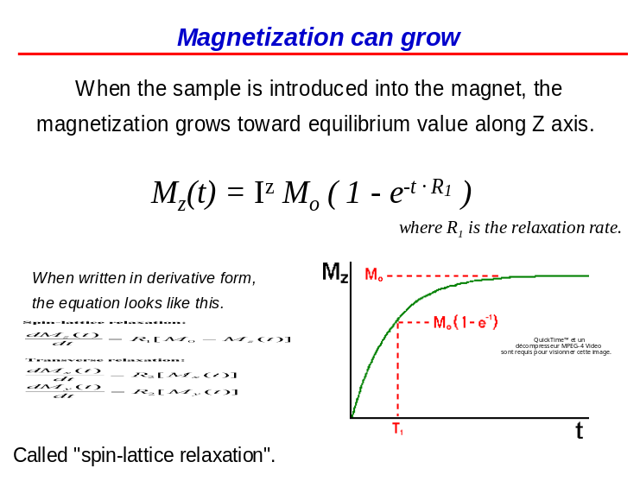

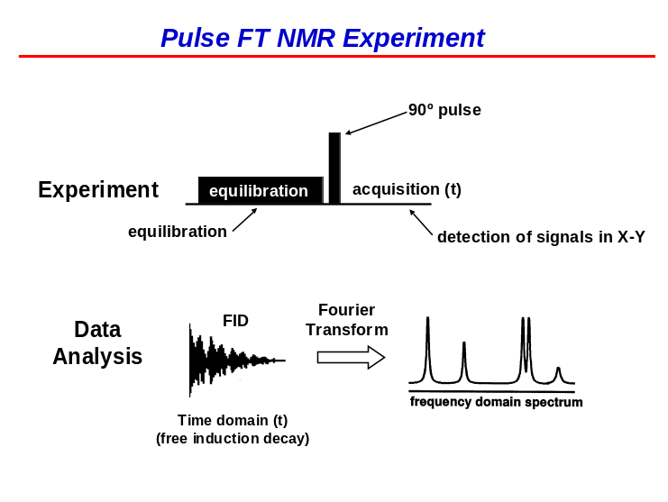
This is what a signal looks like. As they rotate in the x-y plane due to their chemical shift, we get a signal from the voltage in the coil as a function of time as the signal rotates in the x-y plane.

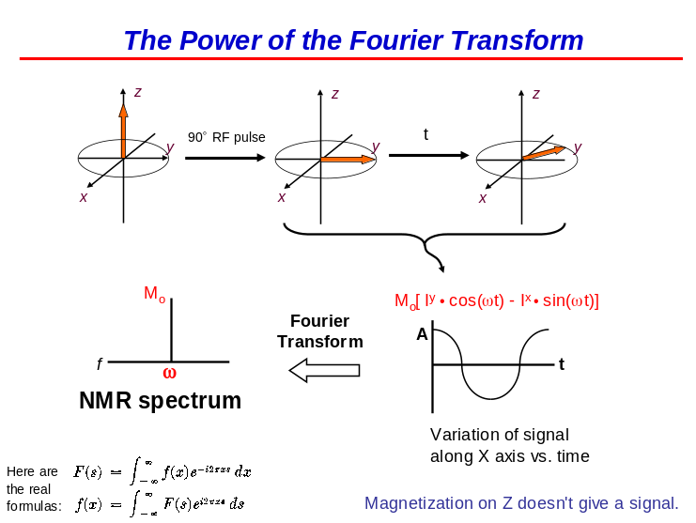
This is the Fourier Transform (FT). It converts the sine and cosine functions (waves) into a spectrum with frequencies having peaks at each of the corresponding frequencies in the sine and cosine waves. So here, we have it in the product-operator form. The magnetization starts off at 0 and slowly equilibrates over a few seconds to yield a magnetization on the z-axis. Then we do a 90◦ degree pulse; put it into the x-y plane. Now it rotates at a rate ω (the chemical shift) for different periods of time. If you plot the projection along the x-axis i.e. measure the voltage from the coil, you’ll get a sinusoidal variation of the signal. We’ve been looking at the product-operator form where the magnetization is either on the y-axis or the x-axis and it rotates using a sine and cosine term and it’s the total amount of magnetization

magnetization that we obtain at the beginning when the sample relaxes. Then we do the FT do get the spectrum which has a single peak at the wavelength of the frequency when the chemical shift is ω. A more important point is that magnetization along the z-axis doesn’t rotate because there is not effect there. Therefore, we don’t see any signal for magnetization on the z-axis. Without a 90◦ RF pulse, we’d get no signal! So we need to do a 90◦ RF pulse to get the signal in the x-y plane which then rotates. We’re not going to talk about the real FT but rather, treat it as a black box. Hence, we’ll remove ω from the sine and cosine terms which gives a peak at ω.
Here we have two signals. They both develop z-magnetization during the equilibrium time. Following the RF pulse, they will be in the x-y plane and will begin precessing with time. If ω is different for the green and the red vectors, the magnetization will be pointed at different axes. They will therefore have different frequencies and we’ll see two peaks in the NMR spectrum.

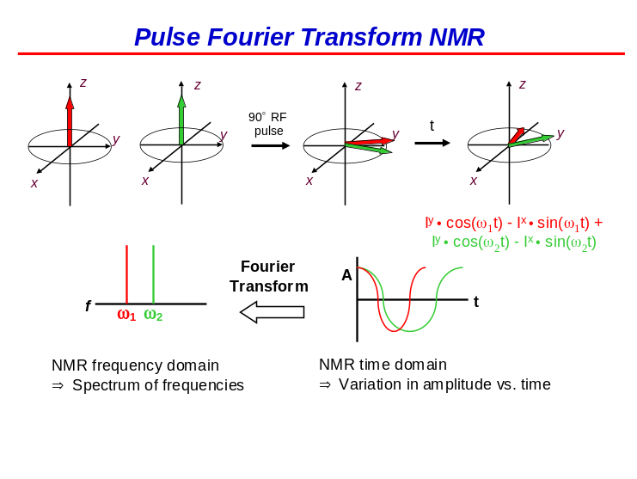
If frequency is zero i.e. the peak is on resonance, then there is no oscillation and all you see is the slow decay of the signal as it decreases in the x-y plane (refer to “Magnetization Decays” slide for equations describing this phenomenon). In the first case, there is no “wiggle”. If you’re off resonance i.e. ω ≠ 0, then we see some oscillation. The further we are from the center of the spectrum, the faster the signal will oscillate. The important concepts are 1) you can get some indication on how fast the signal oscillates and 2) the longer the signal oscillates, the sharper the obtained peak is. For example, if you have a signal that decays quickly

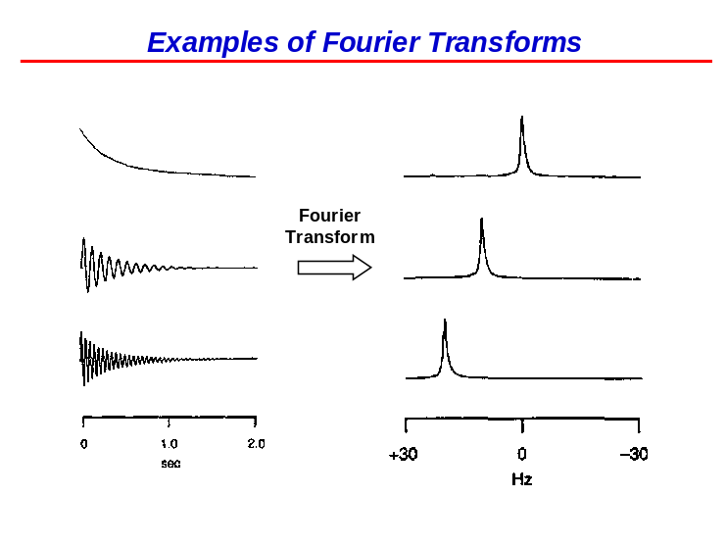

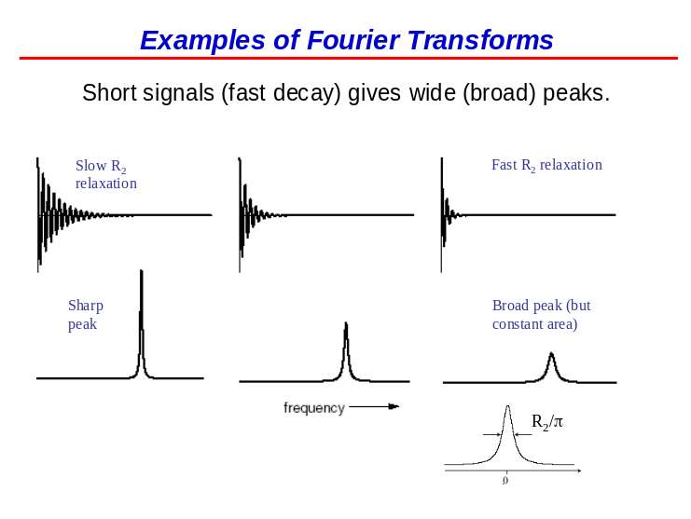
For example, if you have a signal that decays quickly in the x-y plane (because it has fast relaxation), then you only see a few oscillations before the signal disappears. When you do the FT, you obtain a broad peak. If you have slow relaxation, you get high frequency information in the time domain spectrum which yields a sharp peak. One thing that is constant, however, is the area of the peak because the area is related to the number of protons (and the M₀ in the “Magnetization Decays” equations). There is a formula for the width of the peak which is linearly related to the relaxation rate. The FT is inherently done with imaginary numbers and a complex plane of imaginary numbers. But we don’t have to worry about that.

Here, we start with magnetization in the x-y plane. It decays without any oscillations, so ω = 0. When we do the FT of it, we get a solid line i.e. the real signal and an imaginary (dotted) line i.e. the dispersive signal. What we really measure are signals that are in the x-y plane. You can get signals which look real if they’re on the y-axis or dispersive if they’re on the x-axis (as for this example). If they’re on the –y-axis, it’s going to be –1 times the real signal so it will be the mirror image (downwards). You can have signals that are 45◦ which are between the x- and y-axes where you’d get the sum of the two signals. When we measure our signal and do the FT, we obtain both real and imaginary signals. Importantly also, magnetization on the z-axis is not seen. We have magnetization on the x-y plane and then we do a FT

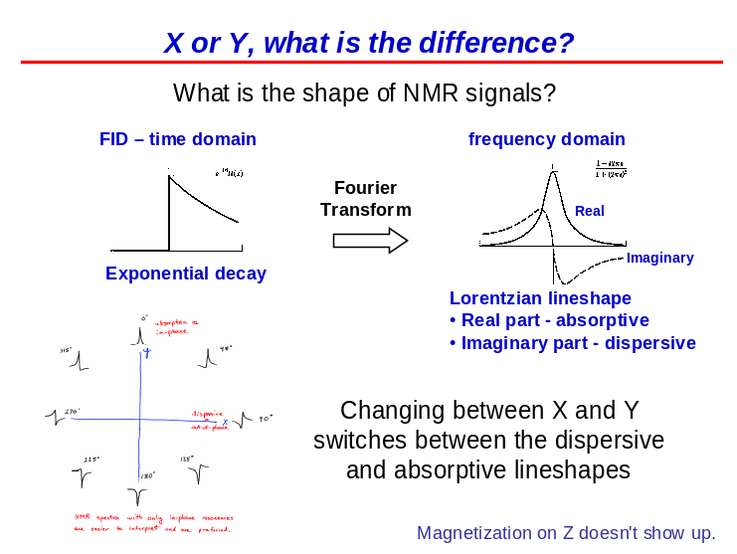
we do an FT. This gives us two signals: one which is on an imaginary axis which we usually don’t look at and another on a real axis giving us a spectrum of peaks.

Question from audience: Do we get a sum of the two spectra? No. We get one which is the imaginary part and the other, the real part. With every ω, you get a phase (please refer to “Examples of Fourier Transforms” slide). Regarding this slide, we see different ώ values which depend on the rate. Fast oscillations have a large ω and slow ones have a small ω. Importantly though, we see the signals all start off at 1 which is reminiscent of a cosine function. However, they could also start at the origin and increase. This refers to the phase of the sine term which is related to the imaginary part. Depending on whether the phase of the signal starts on the x- or y-axis, they will have an imaginary or real shape. In fact, using a spectrometer, a computer can process complex math to determine the axes and thereby change the phases so that imaginary signals become real.

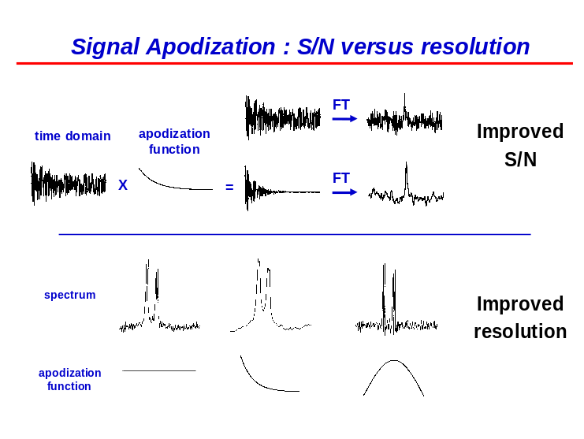
When we record signals, we have a lot of noise. On the left, we see a signal which will be digitally processed to improve the signal/noise (S/N) in the spectra. Two simple examples are shown. We take an exponentially decaying function which we use to multiply with our signal. We obtain another time domain spectrum to which we apply an FT to generate a “nicer” peak than the one shown above this displaying an FT of the original signal. We’ve improved S/N quite a bit. Before, the noise was almost as high as the peak and we have S/N = 2 (where the signal is twice the height of the noise). While after signal apodization, S/N ~ 4. However, there is a drawback. Initially, the signal decays slowly whereas after apodization, the signal decays more quickly due to its multiplication with an already

already decaying signal. When the signal decays faster, the resulting peak broadens. Thus, we can improve S/N, but we lose resolution. We can also do the opposite. Instead of multiplying by a function that decays, we multiply the signal by an increasing function to improve the relative size of the signal at higher frequencies which gives a sharper peak but with poor S/N compared to doing no multiplication at all or just broadening the peak. At the bottom of the slide, we see multiplication by 1 to generate a different spectrum. Then we see a broadening and finally the signal is much sharper.
We don’t have to record just 1 signal. We can record signals many times and add them together. Doing this yields a higher S/N ratio. The formula on the left from statistics describes the phenomenon of coherently adding signals together meaning that if you add two signals, the signal will be twice as high, 100 signals will give a signal that is 100 times as high and so on. However, the noise does not add coherently. It increases as the square root of N (the number of signals). Thus, 100 signals with noise will give a final noise value 10 times larger than in a single scan. We are interested in S/N. If the signal increases by a factor of 100 and the noise by 10, then the improvement in the S/N value is 10 versus recording a single scan. On the left, the peaks are the same size whereas the noise is 10 times

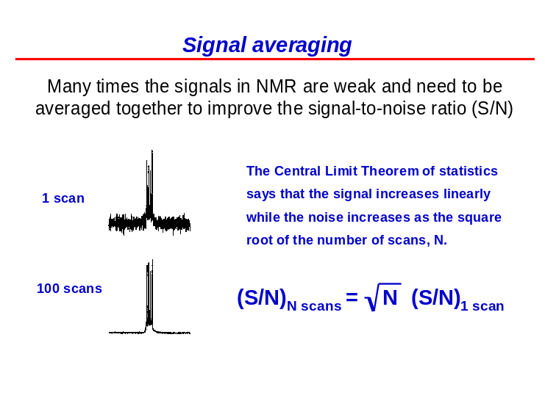
times larger in the top spectrum relative to the one below. If you take N scans together, then your S/N in the resulting sum is going to improve by a factor of √N x S/N.

We’ve looked at the quantum mechanics representation of NMR. Most of the signals are weak because there is a small difference in the population between aligned and anti-aligned signals. There is also a classical representation for NMR where the bulk magnetization, M₀, comes from the addition of all the nuclei in the sample. If you take all of the spins together, taking into account the small aforementioned difference, there is bulk magnetization in the sample represented as M₀ at time t = 0. If you use RF pulses or chemical shift, you can see how the vectors rotate (either on the x- or z-axis). On the bottom right of the slide, we see the formula we’d obtain for the signal. We start with a magnetization at equilibrium, it decays (we saw the exponential decay term in the Bloch equation i.e. e^{-tR2}). The

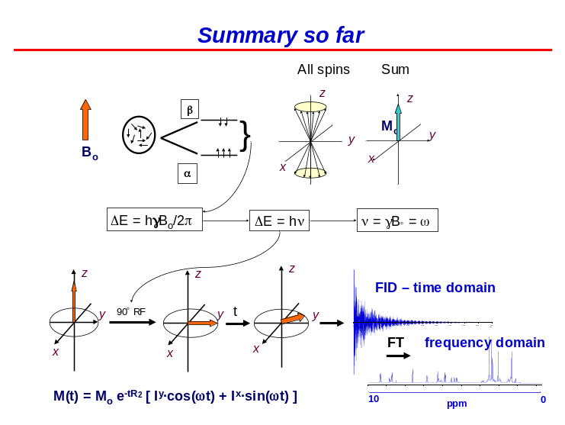
The magnetization precesses or rotates in the x-y plane written mathematically as a sine function with the ώ term (the rate of rotation) and t (relating the magnetization at any point after the 90◦ RF pulse). After the pulse, corresponding to t = 0, bulk magnetization rotates as t increases in either the I^{y} or I^{x} axis and will then decay. We can then do the FT with the varying signals which gives us our spectrum with frequencies and phases for each of the peaks. Relating to peaks, we talked about their frequencies, centers, widths (and/or the width at half its height), the total area and height.
Dr. Gehring presented ω as the rotation of the magnetization which is never really zero. Usually, we compare ω to our reference frequency and always look at the differences. There is a difference in the reference frequency (which can be provided by water or DSS) and the actual chemical shift. We use ppm values because the difference in frequencies for protons in various chemicals is very small. All protons in a 14 T magnet rotate at 600 MHz. However, the ones on methyl groups rotate slightly faster than the ones on aromatic compounds. The difference here is so small that you have to multiply the signal by 1 million in order to get it into reasonable units. For example, the difference between a methyl group in TMS and a methyl group on the nitrogen side-chain of Trp is about 10⁻⁵ relative to the total frequency difference.

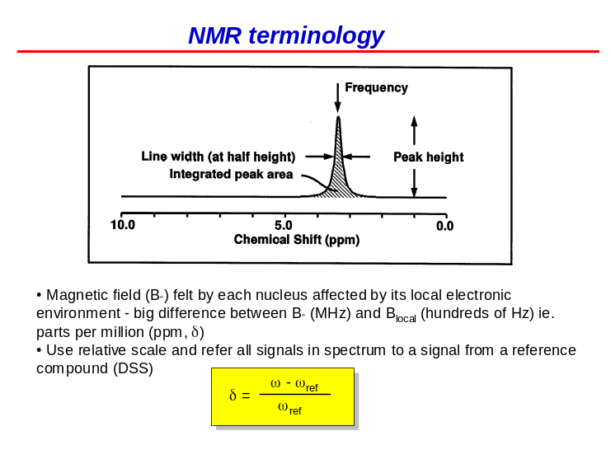

The differences in frequencies between, for example, a proton in TMS and one in CHCL₃ (which resonates at about 7.5 ppm, as shown in the slide on the left) are accounted for by the shielding of the electrons around the nucleus. This effect accounts for most of the differences in frequencies between protons in different compounds. We’re really just measuring the electronegativity in the environment of the nucleus. If you have very electronegative groups such as Cl, protons become strongly deshielded (has fewer electrons), its magnetic field is therefore stronger and at a higher frequency or larger ω value. In contrast, a less electronegative group like Si will have more electrons. We can think of electrons as small umbrellas. The magnetic field rains down on the nuclei and if the nuclei have many electrons, their umbrellas shield them well

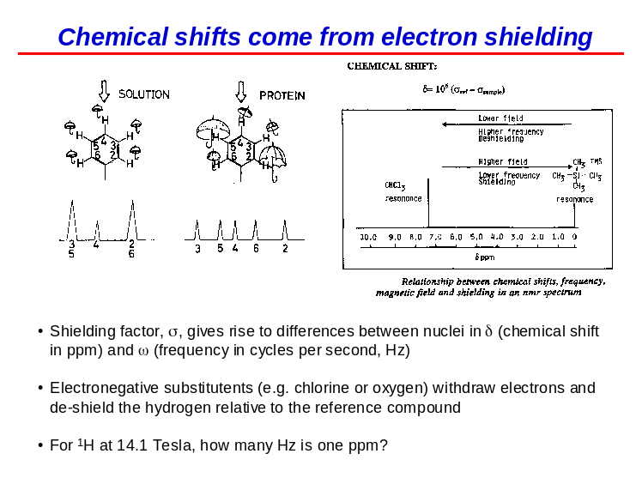
nuclei have many electrons, their umbrellas shield them well and they will be found at smaller chemical shifts relative to TMS. On the other hand, if they have few electrons as they would in proximity to an electronegative group like O, N or a halogen, they have fewer electrons shielding the nucleus and are found further downfield on the chemical shift spectrum. To clarify, downfield is where the numbers are larger and upfield is closer to the TMS reference peak. Historically, this terminology comes from the very first spectrometer where the frequency was not measured. Rather, the magnetic field needed to add or subtract in order to get the signal to a certain frequency was measured. It used to be easier to vary the magnetic field and keep the frequency constant whereas today, we used magnets with constant fields and measure either a lower or higher frequency.
This is the spectrum of a peptide. We see the TMS reference peak at 0 ppm, the signal for methylene protons, water, aromatic compounds and nitrogen protons. We need to learn the 7 regions of the spectrum to then be able to assign peptides. To do this, we must recall that the amide protons are at 8 ppm, the methyl protons are at 1 ppm and the H^{α} are at 4.5 ppm. Dr. Gehring will give us a spectrum of a peptide on the final and we’ll have to assign it. At the top of the slide, we have the peptide’s spectrum in water. We can also put our sample in D₂O (as mentioned in the MS lecture series). Some of the protons in proteins are labile.

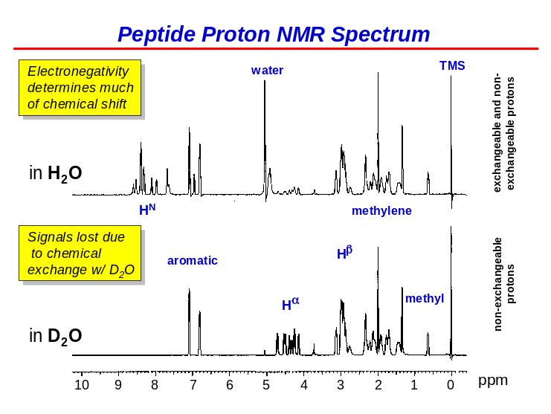

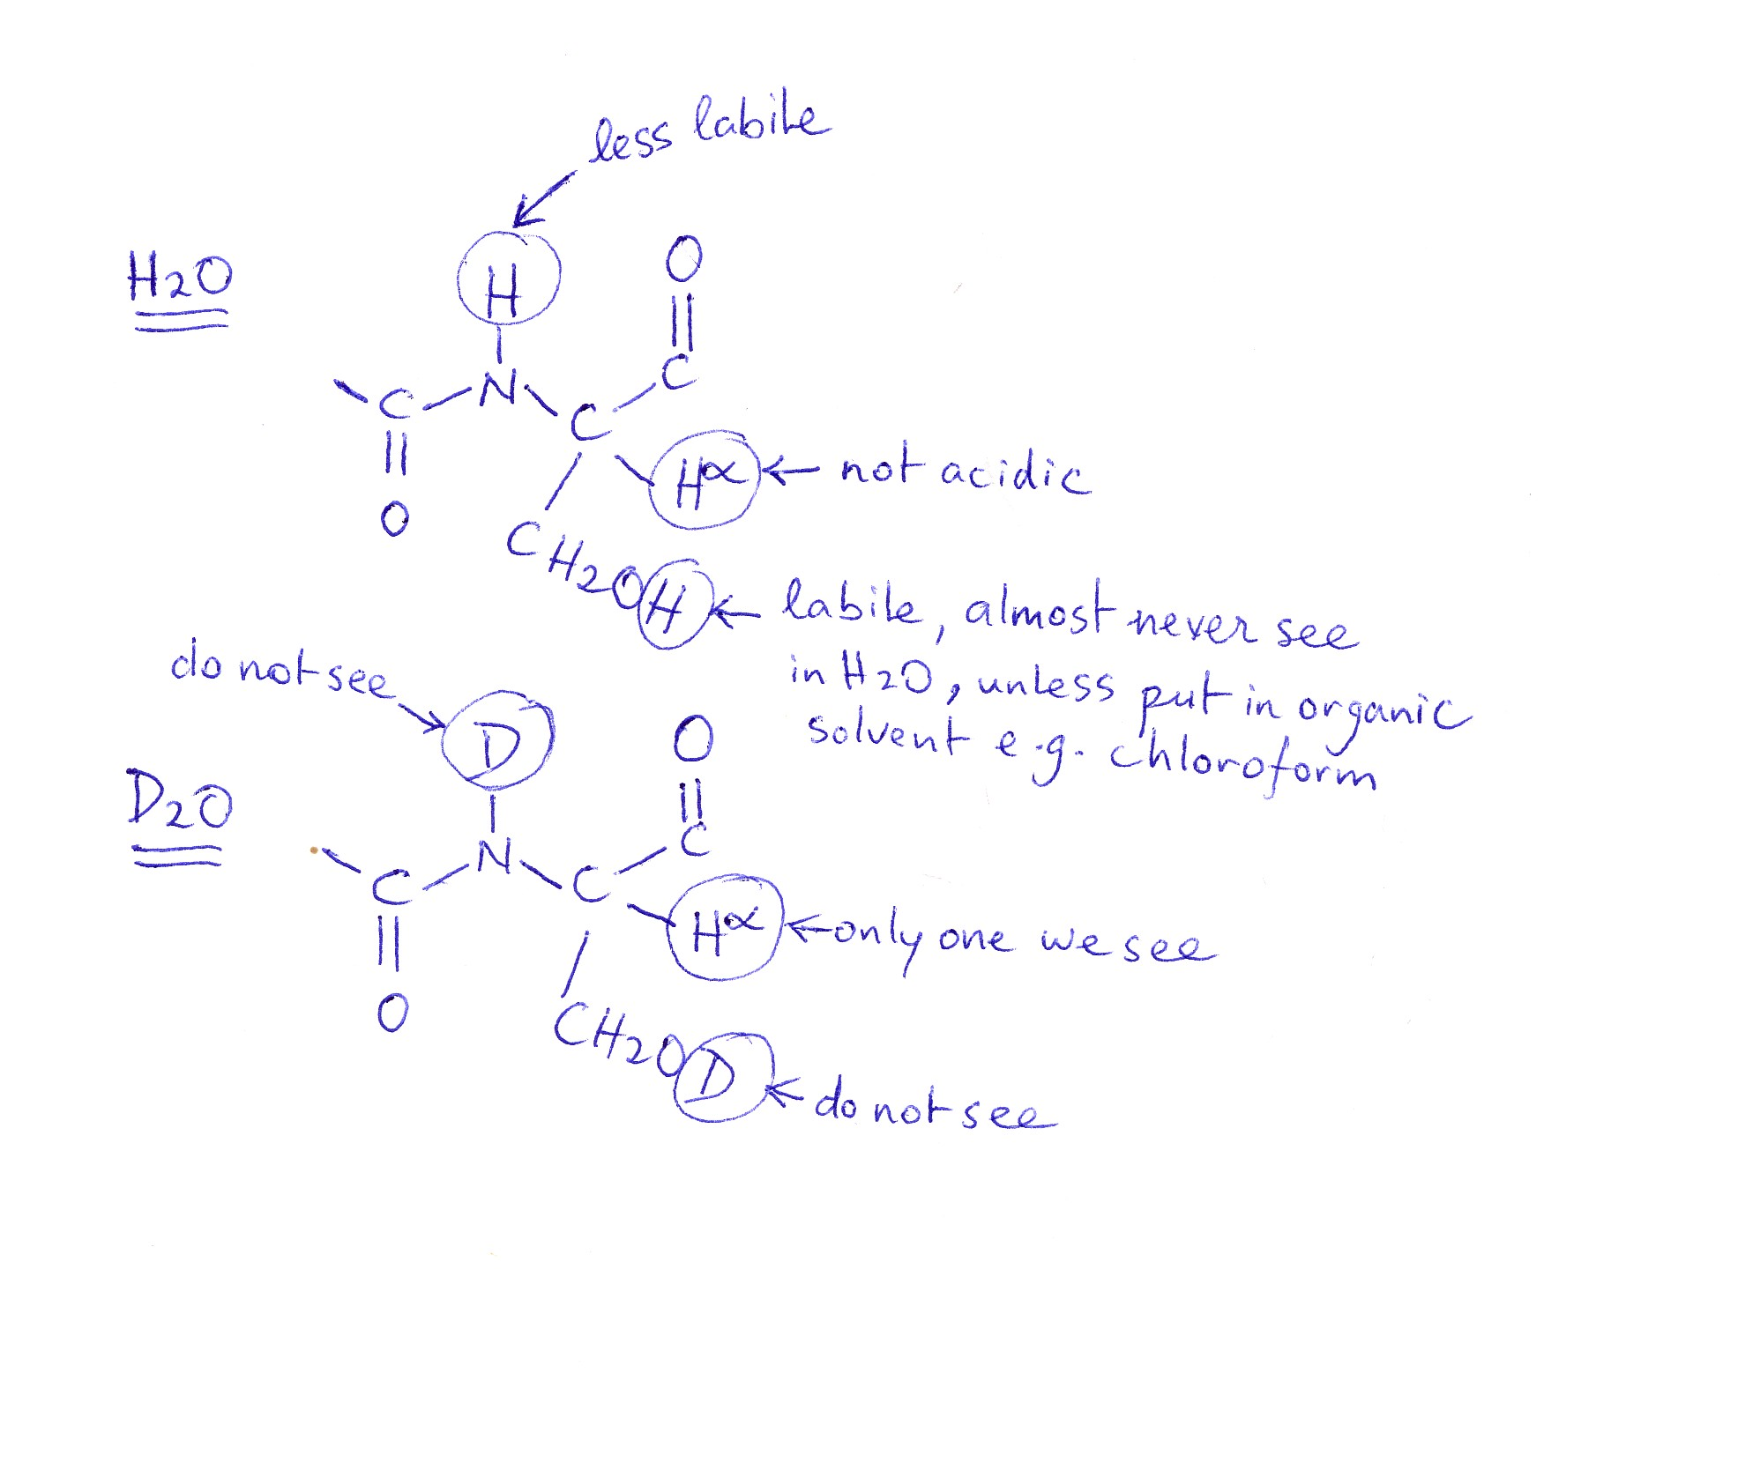
Some of the protons in proteins are labile such as the protons in hydroxyl groups which are so labile that we do not even see them in water because they’re constantly going on and off the peptide. They mostly hide under the water signal in the spectrum. We only see these types of protons when proteins are immersed in organic solvents like chloroform. The next ones we’ll look at are amide protons. These are less labile on the rates of seconds to minutes which is long enough for us to see them. Signals from H^{α} never exchange and therefore are not acidic. We can distinguish between the amide protons and the H^{α} signals by taking the protein from H₂O and putting it into D₂O. If you do that and wait for the necessary seconds or minutes, you can actually watch the signals disappear because they’ve been

been substituted by deuterium atoms. If you look at the spectrum in D₂O, the hydroxyl group becomes deuterated within milliseconds and over a time course of minutes, the nitrogen becomes deuterated as well. These signals are therefore not seen any longer. The only signals that remain are those from H^{α} and H^{β}, the ones in methyl groups or in aromatic rings. By doing the comparison of the spectrum in H₂O and D₂O, we can tell that in the above figure, the two donshifter

the two downshifted peaks are from aromatic rings whereas the one in the middle is not because it exchanges and disappears. There is another reason why we do spectra in D2O vs. H2O which has to do with the relative amounts of water and protein found in the sample.

The concentration of water, as you recall, is 55 M. The protons on water give a signal of 110 M (because there are two water protons) whereas for proteins, they will be on the order of 1 mM. There is a difference then of about 10⁵ between the water signal and the proton signal of the protein. We do not see this large difference in the spectrum because we remove the water signal in order to get a spectrum. Had we not done that, there would only be 1 peak 100 000 times taller than the peptide protons which would then be very hard to see. There are many ways to suppress water signals and they have different advantages. However, an important disadvantage is that this suppresses any signals close to water. When we look at the H^{α} signals, they have been attenuated in the presence of 110 M water. The spectrum is a good one because the H^{α} are close to water, which is 100 000 times higher, yet we still see them. We can therefore use different techniques for hiding the water signal but if you can substitute the water with D₂O, then we do not have to try so hard to get rid of the water signal. In the slide above, we see the residual water signal in D₂O. There are some proton signals because the D₂O was not completely pure probably due to the absorption of moisture by the sample when opened up to the atmosphere. Therefore, we get some protons in our D₂O spectrum but by removing them, we get a much better spectrum for the H^{α}.

The two points here are that 1) electronegativity is a key determinant for the chemical shift and you can remove signals from the exchange of protons when placing a sample from H₂O to D₂O.

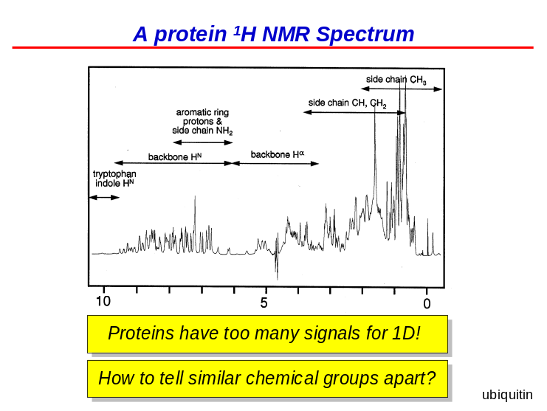
We can go up in molecular weight from peptides to protons and so, the number of signals increases. At some point, there are two many signals to separate in 1D spectra. A solution to this is 2D spectra.

If two peaks overlap in 1D, using 2D spectra will resolve them. If there is still some overlap, you can carry out 3D spectra which allow us to work with proteins that are over 200 residues. This is the 2D spectrum of ubiquitin, a 76 residue protein. We see that in 1D, there is a lot of overlap.

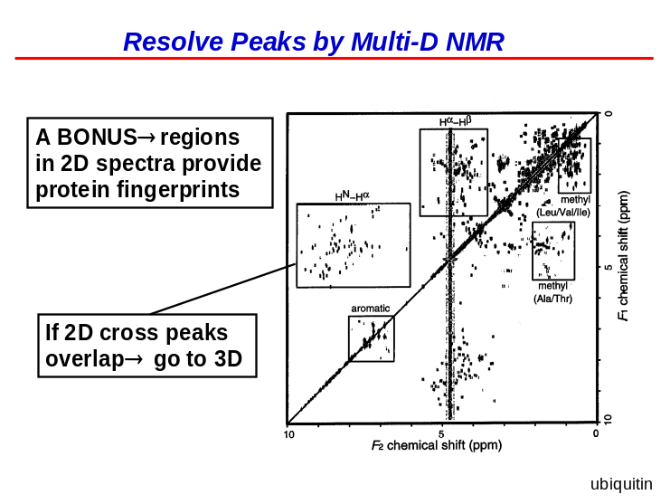
Here we present the general scheme to acquire 2D spectra. We put the sample into the magnet and let the signal grow. We then carry out a 90 RF pulse resulting in a signal precessing in the x-y plane (this is where we measure their frequency). We then go through the mixing phase which allows the magnetization to go from one nucleus to the next nucleus and measure the frequency a second time. We do this by recording a number of 1D spectra and do two FTs. We do the 1st FT in one dimension to get peaks in the spectrum and then we do the 2nd FT in the 2nd dimension which allows us to calculate the frequency from the 1st time we measured the frequency yielding peaks in 2D.

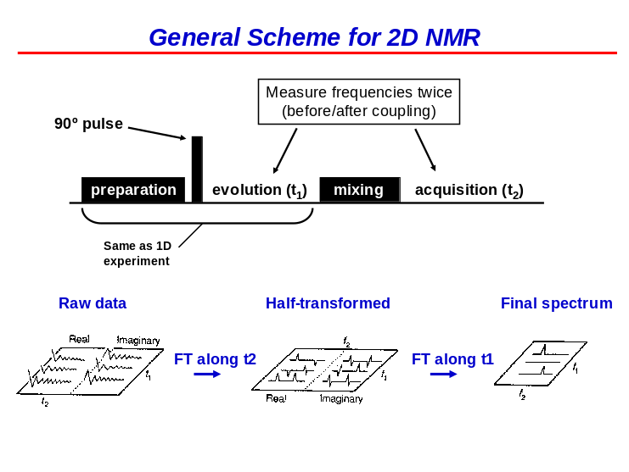

If you do the FT in one dimension, you’re going to get your peak. Depending on what you do in that first period, sometimes the peak will be small and other times large and that means that in the series of 1D spectra, the signal will increase and decrease and be positive, negative or zero. If you take a line along those peaks, and plot them, you obtain this oscillating signal shown on the left. This is basically how you do the FT of the signal to get a second peak.

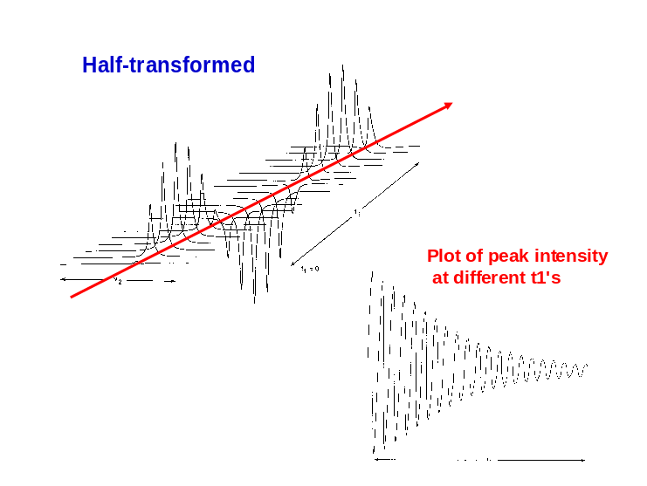
We’re going to look at product operators once more by revisiting Practice Problem 3. Here we have two protons in our sample. We’ll start by putting the sample in the magnet, the magnetization will grow, we’ll follow with a 90◦ RF pulse which will rotate the two arrows in the –x-axis (which is the same as a 90◦ RF pulse leading to rotation around the +x-axis). So now we obtain magnetization for the two protons along the I^{y} axis. Now we’re in a period of magnetization in the x-y plane and it precesses.

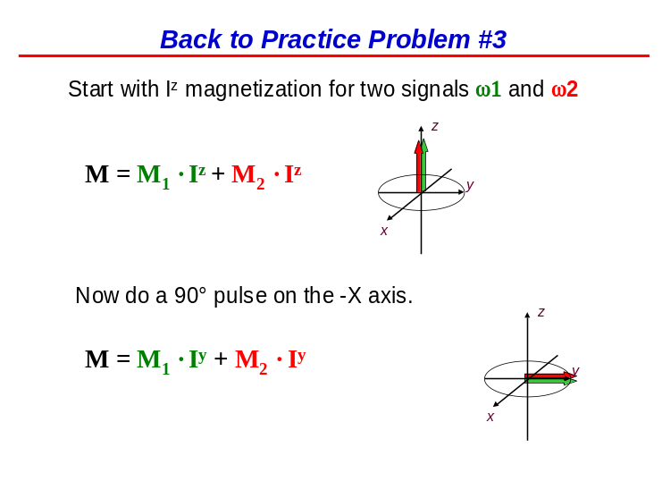
Now we’re in a period of magnetization in the x-y plane and it precesses. The magnetization was along the I^{y} axis for both the green and red signals. Here tau (τ) is used for time instead of t because we use t later on. The cosine term is the part that remains on the y-axis and the part that’s off the axis in either the +x- or –x-axes is the sine term. We have two frequencies, one for the green signal and one for the red. The green one has positive frequencies (or chemical shifts) and the red, negative frequencies. If you have a +ω, then the signal precesses in the counterclockwise (CCW) direction whereas if they have a –ω, the direction of precession will be clockwise (CW) when looking along the z-axis. When we measure different τ values, we can determine if the signal went all the way around and stopped at a certain place. This is an important phenomenon

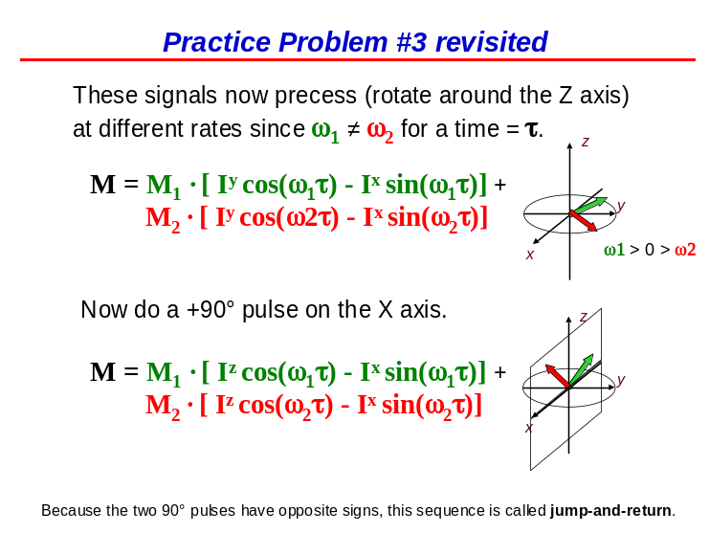

certain place. This is an important phenomenon in NMR called aliasing in that if we only measure τ once, we don’t know how many times the signal rotated before reaching its final position. To reiterate, we started along the y-axis. The arrows are turning CCW along the –x-axis and that’s why we see a negative sign in the equation. In the top of the slide, we have a formula where we have a double negative term which yields a positive term. Hence, the positive sign in between the two large parentheses. The formula does not depend on a positive or negative ω value; we just see the drawing for the arrows changing. We now do a 90◦ RF pulse along the x-axis and undergo positive rotation. We must flip the plane upwards to yield the two magnetization vectors partly along the x- and z-axes. The amount that’s on the z-axis is just the cos(ωτ) term and the part that’s on the x-axis is the –sin(ωτ) term. This sequence is called jump-and-return because we started with a 90◦ RF pulse and then we did the opposite 90◦ RF pulse.
To see what happens to the normal NMR spectrum, recall that we started off with magnetizations along the y-axis at time = 0. We do a 90◦ RF pulse to put the arrows in the x-y plane and then record our signals. We’ll get two signals: one with a + ω and the other with a –ω. Here, M₁ doesn’t have to be the same as M₂ because they may have had protons in different environments.

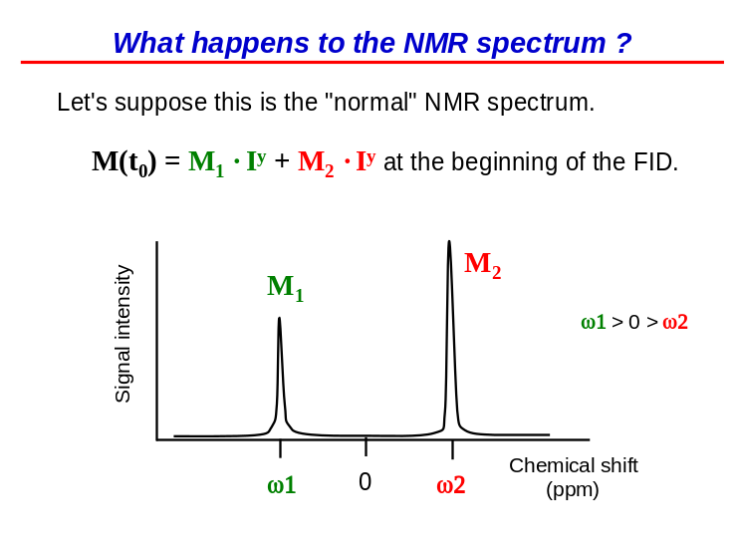
After the jump-return sequence, what is the magnetization? Well now we have part of it on the z-axis and part on the –x-axis which is the same for both protons. Since magnetization on the z-axis is not seen, we can drop the I^{z} terms in the above equation on the slide. We then rearrange the terms to obtain the form shown on the left.

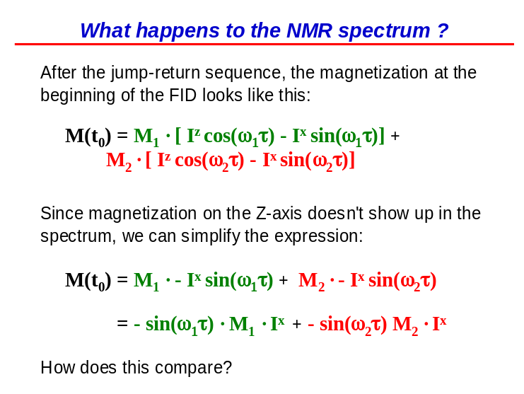

Here we have M₁ and I^{y} for the normal spectrum whereas in the jump-return equation, we have a –sin term and I_{x}. There are two differences: I^{y} vs. I^{x} and we have M₁ vs. M₁ multiplied by an extra term containing some delay ω₁τ. We also have some delay of ω₂τ in the following term.

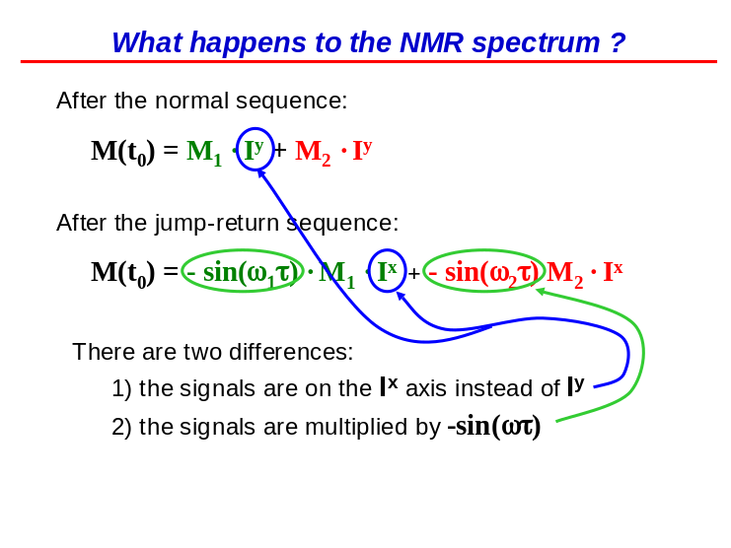

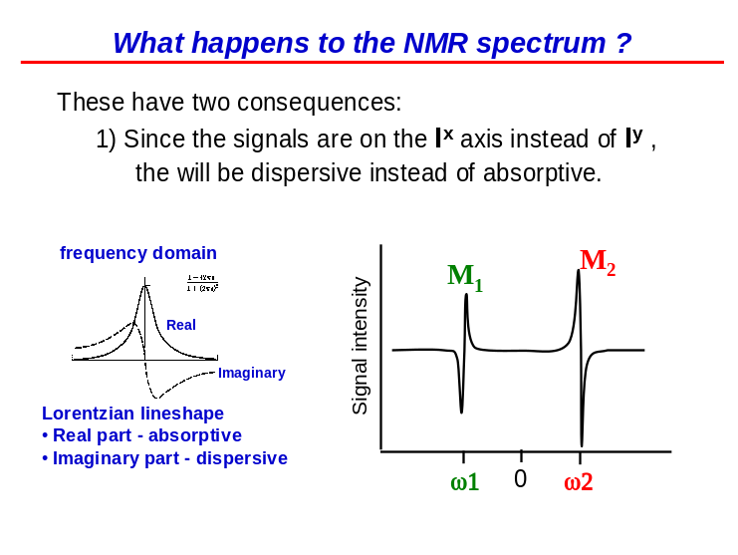
The NMR spectrum will now change. Since we were on the x-axis instead of the y-axis, the peaks will be dispersive (imaginary) instead of the real shape. This is the consequence of the FT detects the difference between the x- and y-axes. This is not that useful. With the spectrometer, we can adjust the phases and we can tell the computer to multiply them by i, to go from imaginary signals to real ones.

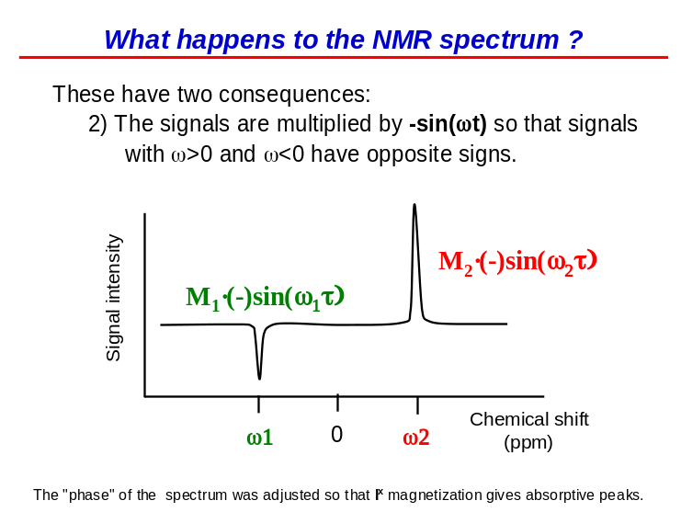
When this is done, we get the real shape but with a portion of the signal being negative and another being positive. Why? Because ω1 was positive and you have a negative sign before the sine term (overall negative) whereas ω2 is negative and there is a negative sign before the sine term again (overall positive). The important point here is that we’ve measured the ω during the first delay. Some of the signals are going to be positive because they have a –ω2 term whereas others will be negative due to a +ω1 term. We therefore separated our signals based on ω in the earlier part of the experiment. By varying τ, you can make a signal positive or negative.

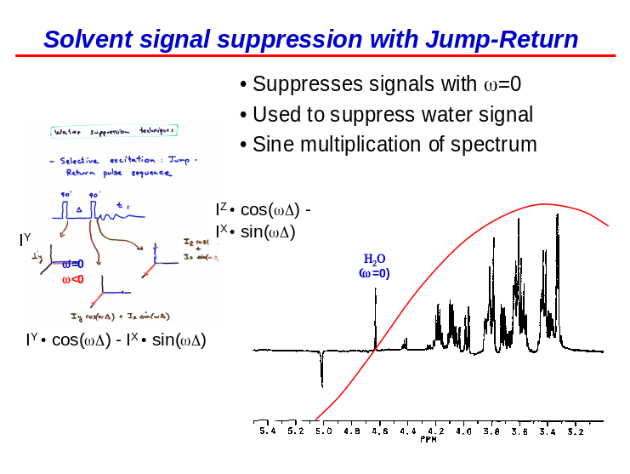
The reason we do these for water is that when ω = 0, the magnetization will go down onto the y-axis (the blue signal – for water) and it’s going to stay there because ω = 0. Thus, the value of τ is irrelevant because the cosine term will always be 1, so the magnetization will stay on the y-axis. If you set the spectrometer so that ω = 0 for water, then the water magnetization is always going to stay on this axis. When you do the return pulse, now the water is on the z-axis and it’s suppressed. This is one of the ways we remove water from NMR spectra i.e. to use the jump-return pulse sequence because the water signal is on the z-axis (which we don’t see). An artifact is generated: the signals on both sides of the spectrum have opposite signs.

